**Create Below Form Page: Order.Html and Survey.html**

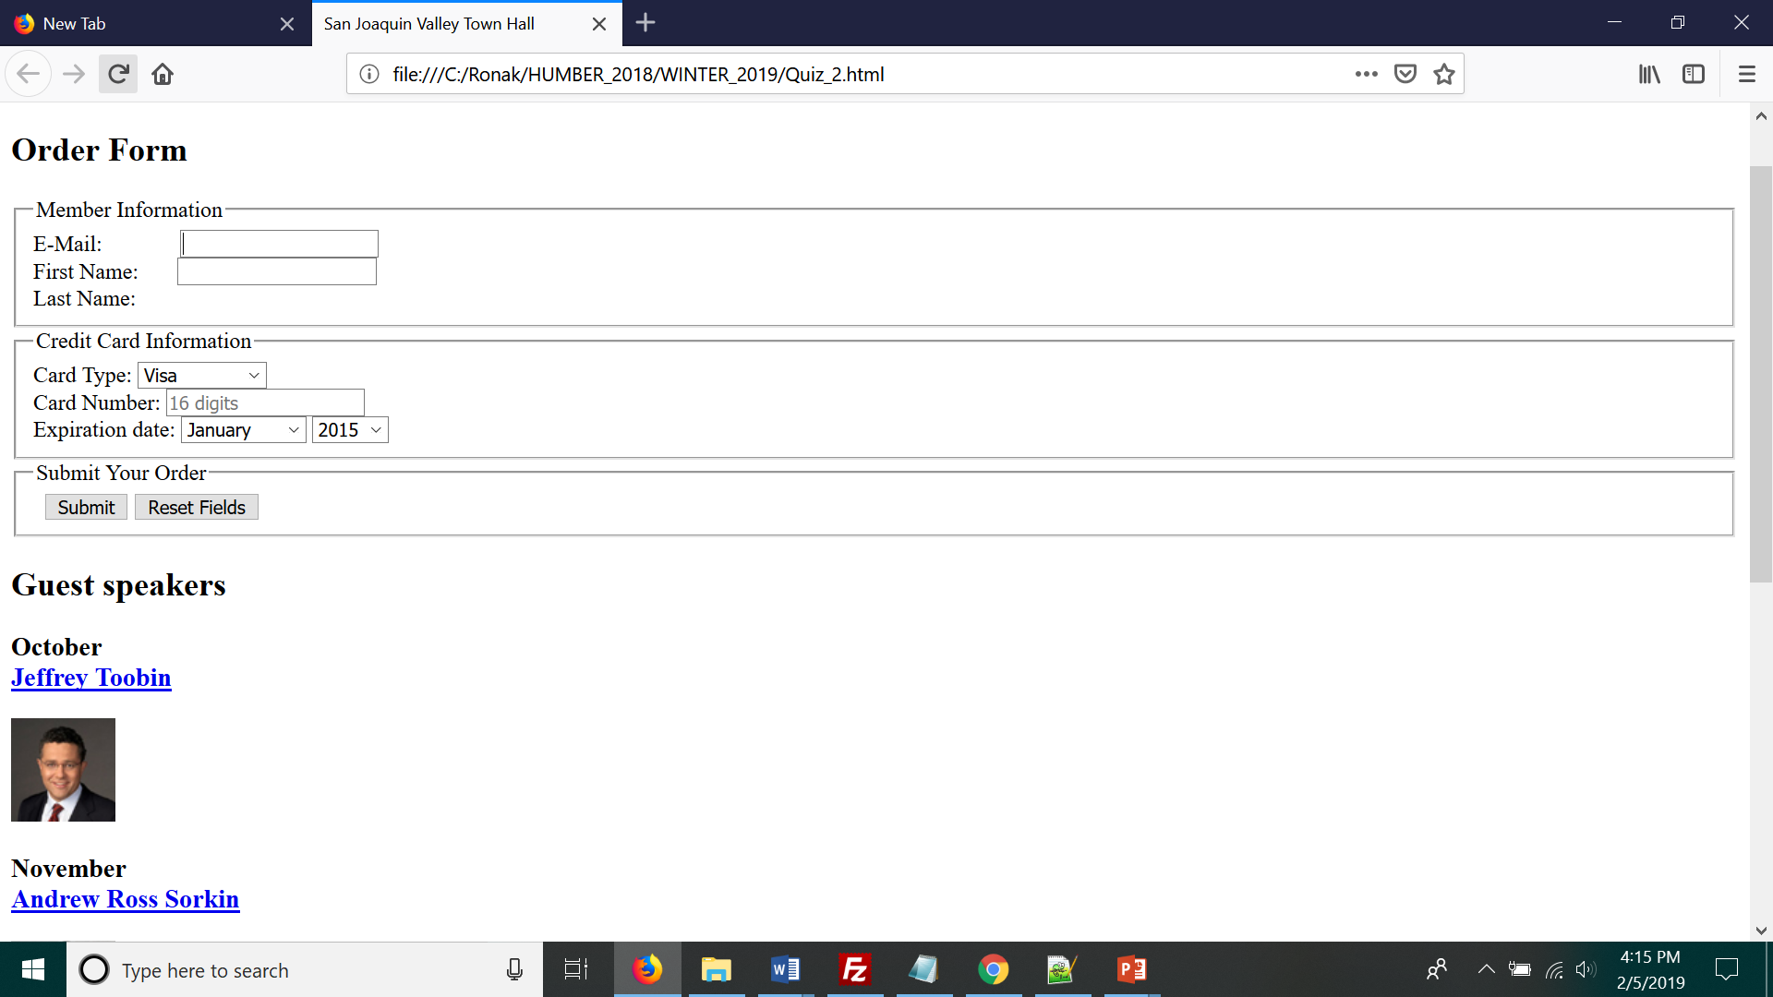

**Order**

**Populate Expiration date with All 12 months and year drop down as 2019,2020,2021,2022**

**------------------------------------------------------------------------------------------------------------------------------------------Survey.html**

-----------------------------